Pneumonia Prediction using X-RAY images

INTRODUCTION:

Overview: -

I have used TensorFlow to create a convolutional neural network with two convolutional layers and one fully connected layer to predict pneumonia, given a chest X-ray image as the input. Then put in an UI so that users can check if they are being affected with it.

Purpose: -

The main purpose of this project is to help the doctors to predict the pneumonia disease more accurately using a deep learning model. The objective is not only to help the doctors but also to the patients to verify whether they have pneumonia or not. By using this model, we can precisely predict pneumonia. A convolutional neural network model is built from scratch to extract features from a given chest X-ray image and classify it to determine if a person is infected with pneumonia. a web is built where the user can upload the x - ray image and the results are shown on the UI.

LITERATURE SURVEY:

Existing Problem: -

A patient suffering from Pneumonia goes to the hospital to take an X-ray image waits for the doctor and then the doctor will check the X-ray then he decides whether the person has pneumonia or not. The results are not only concluded based on just seeing the X-ray images but furthermore, tests were conducted on the patient to verify the results of the doctor. The process is time-consuming and if the patient has severe pneumonia or not, he has to wait several days to get the test results.

Proposed Problem: -

In this work, an efficient model for the detection of pneumonia trained on digital chest X-ray images is proposed, which could aid the radiologists in their decision-making process.  I will use [CNN (Convolutional Neural Network)](https://en.wikipedia.org/wiki/Convolutional_neural_network), thanks to its excellent ability to perform image classification. By the way, here I obtained 85% accuracy on test data which is pretty impressive to me.

THEORITICAL ANALYSIS:

Block Diagram: -

Final Output

Sigmoid

Pooling Layer

Convolutional Layers

Pooling Layers

Convolutional Layer

Chest X-RAY

Software Designing: -

In the main folder, I have created 4 sub-folders namely models, static, templates, uploads. In the models folder, the model which I have created is saved in the form of .h5 file. In the static folder both the CSS and JS files are present. In the templates folder the HTML files which are base and index are present for the designing of webpage. Then in the uploads folder all the images which are uploaded by the user are present, so that those images are sent to the python program. Then we have app.py file where the model has to start the run. For these we must have anaconda IDE for python code to run. We also need Visual Studio for the CSS and JS files to run.

EXPERIMENTAL INVESTIGATIONS:

One of the following tests can be done for pneumonia diagnosis: chest X-rays, CT of the lungs, ultrasound of the chest, needle biopsy of the lung, and MRI of the chest. Currently, chest X-rays are one of the best methods for the detection of pneumonia. X-ray imaging is preferred over CT imaging because CT imaging typically takes considerably more time than X-ray imaging, and sufficient high-quality CT scanners may not be available in many underdeveloped regions. In contrast, X-rays are the most common and widely available diagnostic imaging technique, playing a crucial role in clinical care and epidemiological studies. There are several regions across the globe where there is a scarce availability of practiced healthcare workers and radiologists whose prediction on such diseases matter greatly. Computer-aided diagnosis using artificial intelligence-based solutions is becoming increasingly popular these days.  Among the deep learning techniques, convolutional neural networks (CNNs) have shown great promise in image classification and segmentation and therefore are widely adopted by the research community.

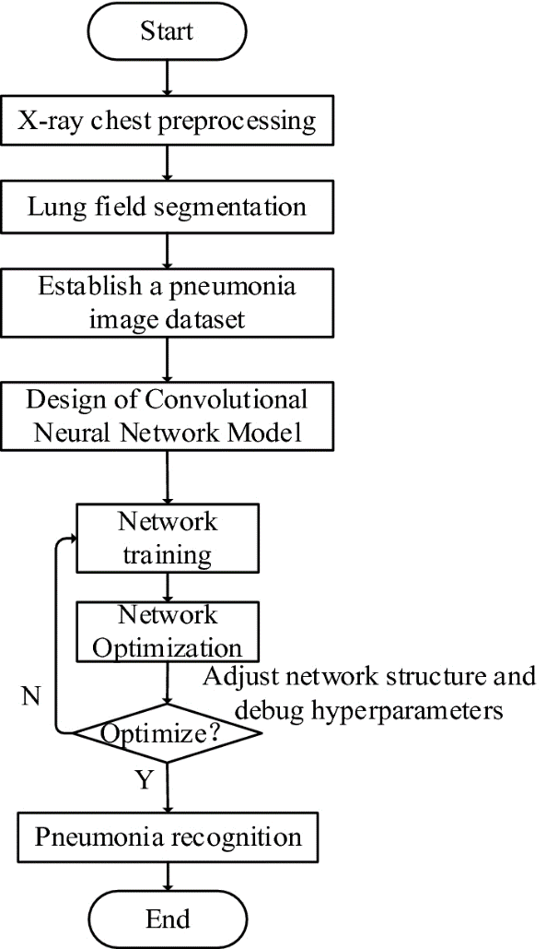FLOWCHART:

RESULT:

Summarizing the testing accuracy and testing loss for different networks and the final weighted classifier. This model was able to attain the maximum testing accuracy and the minimum testing loss. Initially, all the weights of the weighted classifier were kept random. A test accuracy of 85% and a loss of 0.087 was obtained.

ADVANTAGES OF THE MODEL:

The main advantage of CNN compared to its predecessors is that it is capable of detecting the relevant features without any human supervision. A series of convolution and pooling operations is performed on the input image, which is followed by a single or multiple fully connected layers. The output layer depends on the operations being performed.

DISADVANTAGES OF THE MODEL:

1. One of the limitations of this approach was the scarcity of available data. Usually, deep learning models are trained over thousands of images. Training deep neural networks with limited data might lead to overfitting and restricts the models’ generalization ability.
2. Another limitation was that the results of the deep learning models could not be properly explained. A deep understanding of the radiological features visible in chest X-rays is required for the diagnosis of the disease from the X-rays.

APPLICATIONS:

Web application is the most common platform in order to detect whether a person is suffering from Pneumonia by just sending the image to page and the prediction is also given.

CONCLUSIONS:

Through this paper, the automatic detection of pneumonia in chest X-ray images using deep transfer learning techniques was proposed. There is lot of overfitting, so I had to eliminate few images from the data set then, I could see slight increase in the accuracy. While increasing the epochs it took a bit time but the accuracy of the testing data set is high.

FUTURE SCOPE:

Though many methods have been developed to work on this dataset, the proposed methodology achieved better results. In the future, it would be interesting to see approaches in which the weights corresponding to different models can be estimated more efficiently and a model that takes into account the patient’s history while making predictions.

BIBLOGRAPHY:

* I have taken the data from Kaggle. <https://www.kaggle.com/paultimothymooney/chest-xray-pneumonia>.
* I have referred through the documents provided by smartInternz <https://thesmartbridge.com/documents/spsaimldocs/CNNcollection.pdf>
* For importing the libraries the <https://thesmartbridge.com/documents/spsaimldocs/CNNflow.pdf>